SMART LIGHTING SYSTEM USING ARDUINO UNO AND LDR SENSOR
Internship Task – 1
Introduction to Embedded Systems & IoT Device Design .
Submitted By :Yogesh Kumar
Internship Organization: MainCrafts Technology
ABSTRACT
This project presents the design and simulation of a Smart Lighting System using Arduino UNO and an LDR sensor. The system automatically controls an LED based on ambient light intensity. The objective of the project is to understand the fundamentals of embedded systems, sensors, and automation concepts. The project was implemented using the Wokwi simulator and successfully demonstrated automatic light control functionality.

1. INTRODUCTION TO EMBEDDED SYSTEMS
An embedded system is a specialized computer system designed to perform a specific function within a larger system. It consists of hardware and software integrated together to perform dedicated tasks efficiently and reliably.
Embedded systems are widely used in consumer electronics, medical devices, automobiles, industrial automation, and IoT applications.

- Real World Applications :
• Smart Home Automation
• Healthcare Devices
• Robotics Systems
• Automotive Electronics
• Industrial Automation
• Smart Agriculture
2. MICROCONTROLLER VS MICROPROCESSOR
Microprocessor | Microcontroller
- It contains only the CPU. | - It contains CPU, RAM, ROM, and I/O ports on a single chip.
- Power consumption is high. | - Power consumption is low.
- Suitable for general-purpose computing. | - Suitable for dedicated control applications.
- System size is larger due to external components. | - System size is compact.
- External memory and peripherals are required. | - Most memory and peripherals are built in.
- Used in computers and laptops. | - Used in embedded systems such as robots, washing machines, and traffic lights.

3. COMPONENT STUDY
- Arduino UNO :
Arduino UNO is a microcontroller development board based on the ATmega328P microcontroller. It is commonly used in embedded systems and IoT projects due to its simplicity and ease of programming.
Features:
• 14 Digital Pins
• 6 Analog Inputs
• USB Programming Support
• 5V Operating Voltage
- ESP32
ESP32 is a powerful microcontroller that includes built-in Wi-Fi and Bluetooth connectivity.
Features:
• Wi-Fi and Bluetooth
• Dual-Core Processor
• Multiple GPIO Pins
• Low Power Operation
- Raspberry Pi Pico
Raspberry Pi Pico is a low-cost microcontroller board based on the RP2040 chip.
Features:
• Dual-Core Processor
• Multiple GPIO Pins
• Supports C/C++ and MicroPython

4. BASIC SENSORS
- Temperature Sensor
A temperature sensor measures environmental temperature and converts it into an electrical signal.
Applications:
• Weather Monitoring
• Air Conditioning Systems
• Industrial Control
- Light Sensor
A light sensor measures light intensity. LDR (Light Dependent Resistor) is the most commonly used light sensor.
Applications:
• Automatic Street Lights
• Smart Lighting Systems
• Solar Tracking Systems
- Motion Sensor
Motion sensors detect movement in an area. PIR sensors are commonly used for this purpose.
Applications:
• Security Systems
• Automatic Doors
• Alarm Systems

5. PROJECT DESCRIPTION
- Smart Lighting System
The Smart Lighting System automatically controls an LED based on environmental light intensity.
Objective :
To develop an automatic lighting control system that switches ON the LED during darkness and switches OFF the LED during bright conditions.
Components Used :
• Arduino UNO
• LDR Sensor Module
• LED
• Resistor
• Jumper Wires
• Wokwi Simulator
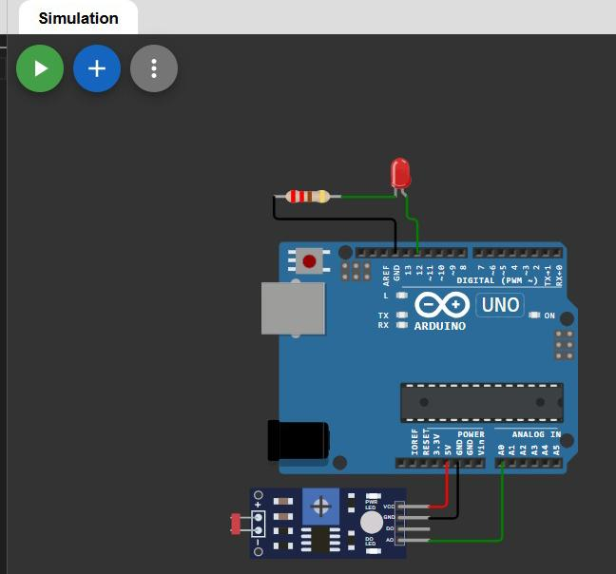
CIRCUIT DIAGRAM :
WORKING PRINCIPLE:
- The LDR sensor continuously measures ambient light intensity.
- Arduino reads the analog value from the sensor.
- During darkness, the sensor value becomes high.
- Arduino turns ON the LED.
- During bright conditions, the sensor value becomes low.

ARDUINO PROGRAM
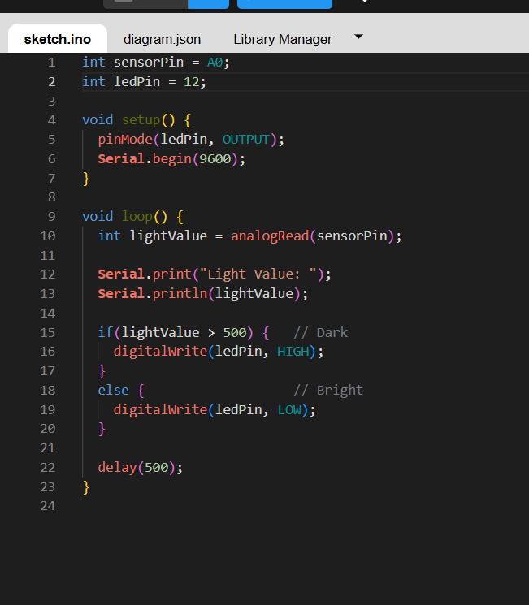
RESULTS AND OBSERVATIONS :
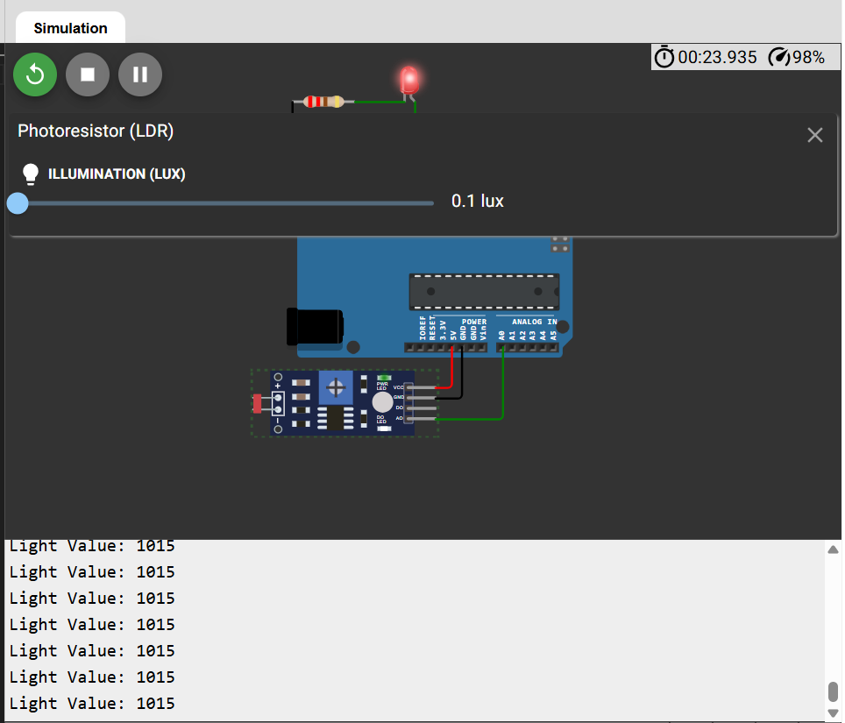
Dark Condition
Sensor Value ≈ 1015
LED Status: ON

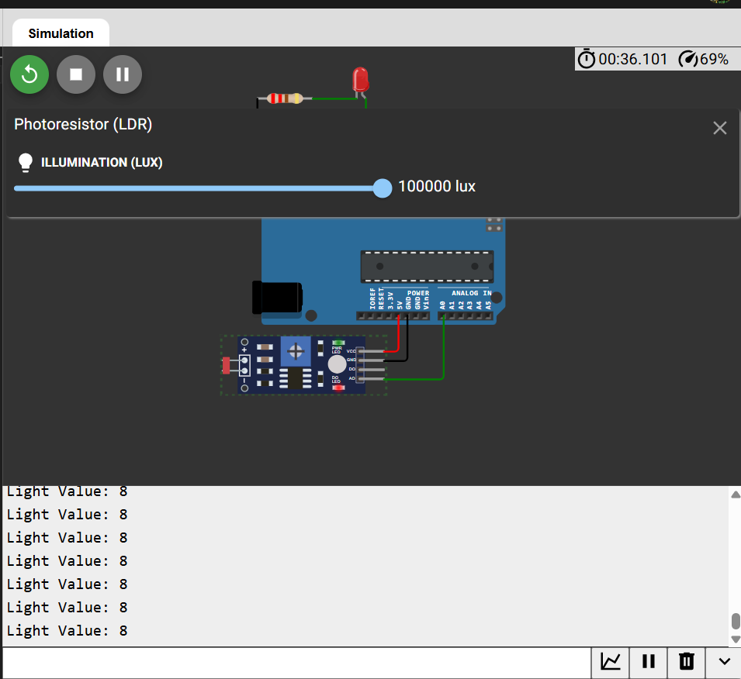
Bright Condition :
Sensor Value ≈ 8
LED Status: OFF

The project successfully demonstrated automatic light control based on ambient light intensity.
APPLICATIONS :
• Smart Home Automation
• Energy Saving Systems
• Security Lighting
• Industrial Lighting Control
ADVANTAGES :
• Low Cost
• Energy Efficient
• Easy to Implement
• Reliable Operation
• Suitable for IoT Applications

CONCLUSION :
The Smart Lighting System using Arduino UNO and LDR Sensor was successfully designed and simulated. The project demonstrated the practical implementation of embedded systems and sensor interfacing concepts. The system automatically controlled lighting based on environmental conditions and can be further expanded into IoT-based smart home applications.
REFERENCES :
- Arduino Official Documentation
- Wokwi Simulator Documentation
- Introduction to Embedded Systems
- IoT Fundamentals

